P2:

B 🡪 C

SRC Port – 80

Dest Port – 7532

SRC IP – B

Dest IP – C

B 🡪 C

SRC Port – 80

Dest Port – 26145

SRC IP: B

Dest IP: C

B 🡪 A

SRC Port – 80

Dest Port – 26145

SRC IP – B

Dest IP – A

P6:

If receiver sends back ACK / NAK with seq # 0 but seq # get corrupted / flipped, sender is waiting at State 2 (Wait for ACK / NAK 0), meanwhile the receiver is now waiting at it’s State 2, at that point deadlock occurs b/c receiver and sender are expecting **different** sequence numbers.

P13:

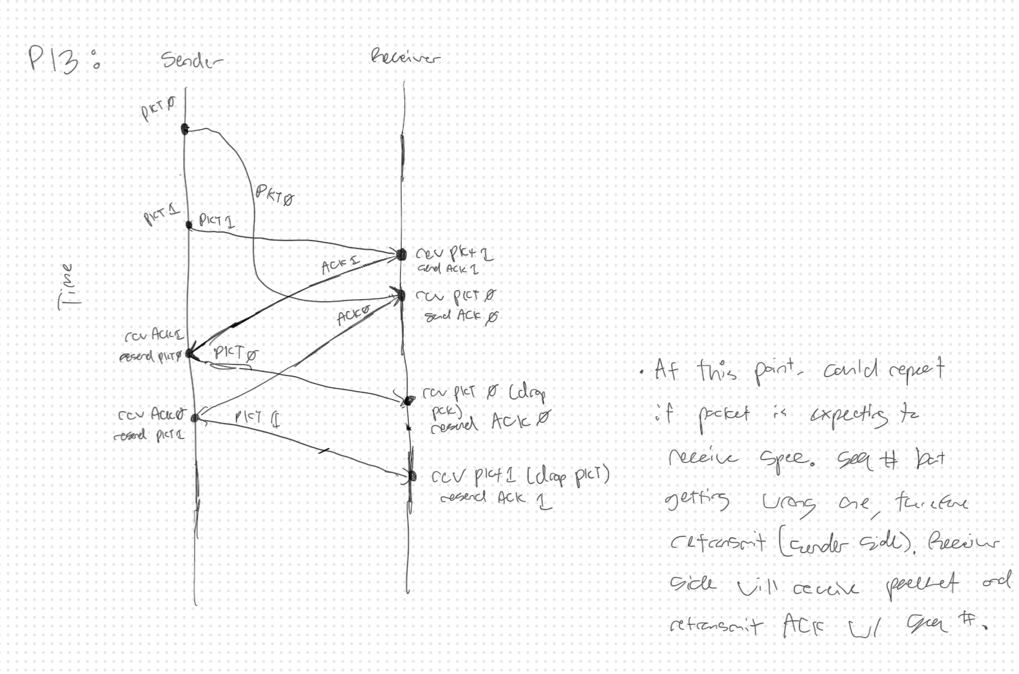

P14:

Both Cases – No, NAK-only RDT Protocol is not preferable over ACK-only protocol. Reason being is that ACK-only protocol makes it easier to determine which packets were correctly received and which ones need to be resent, while NAK-only makes it more complex to determine if packets were received correctly – especially on channels where packets can be sent frequently.

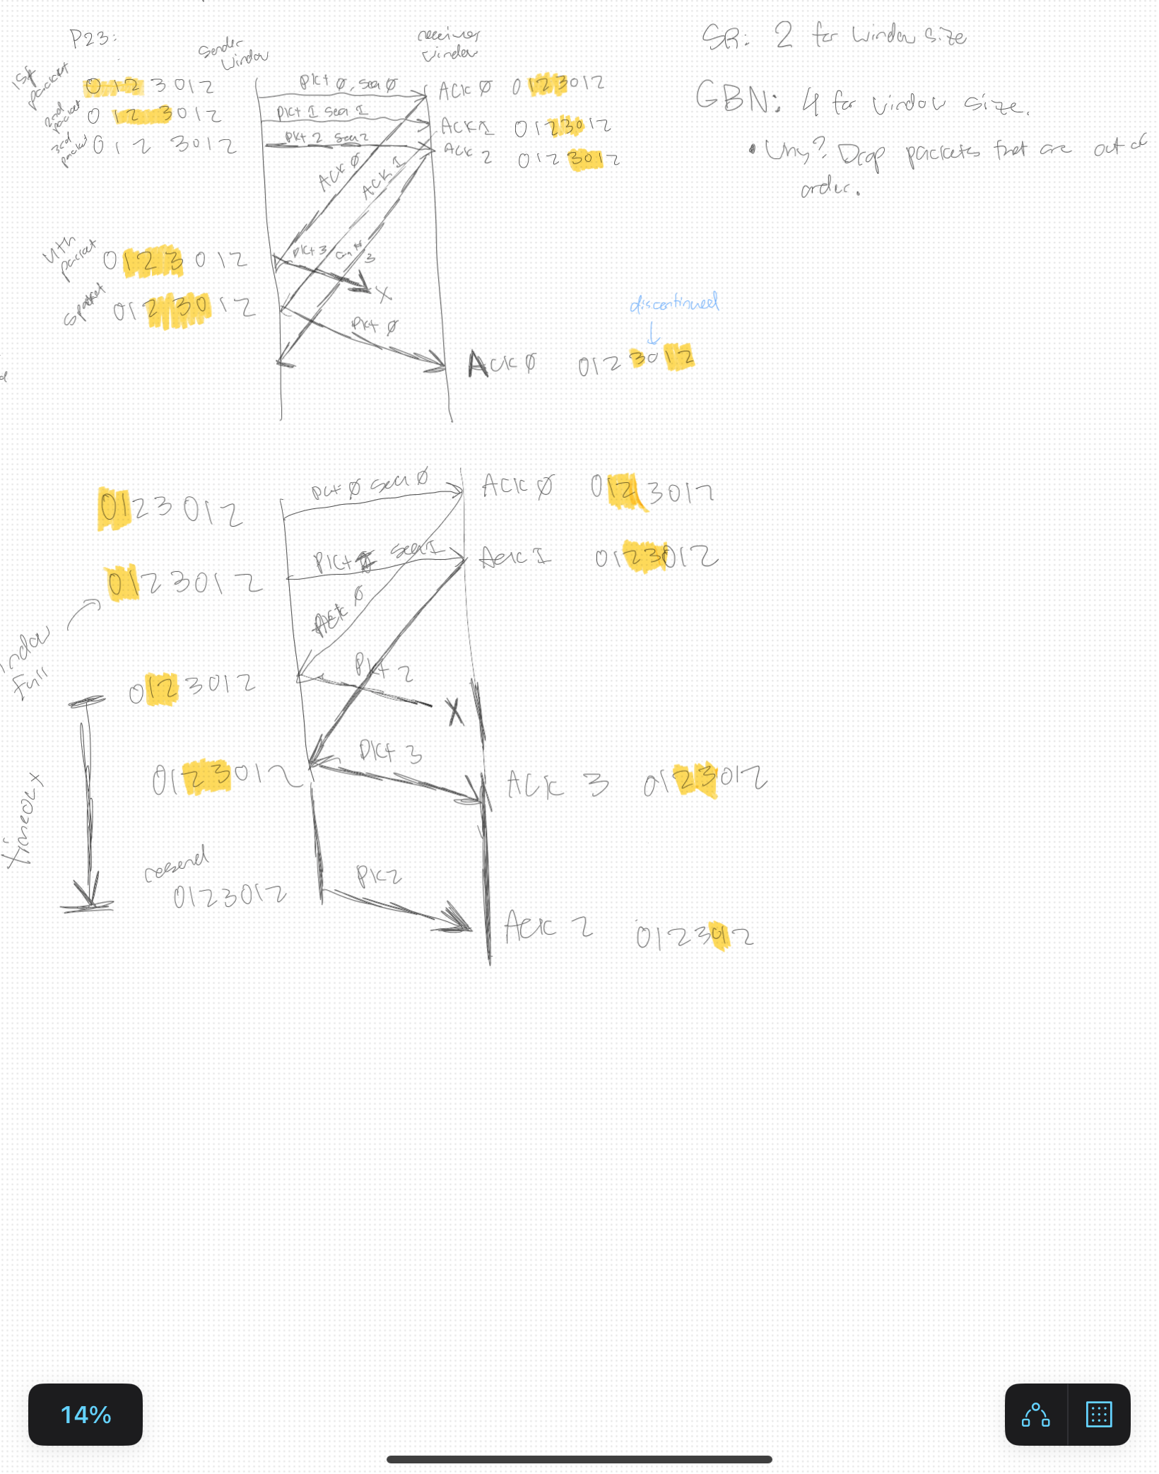P23:

P24:

A) False. Outside of the window, which means that these packets are not going to be sent and expected.

B) False. Outside of window size, which means that packets are not going to be sent and/or expected. Additionally, GBN does not allow for out-of-order packets.

C) True. Updates next packet to be sent when ACK for current packet is received or Retransmit should duplicates be received or timeout occurs.

D) True. Next packet won’t be sent until current packet is ACK’d, just like GBN. Additionally, a window size of 1 means that the packet is in order.

P27:

A)

SRC – 302

Dest – 80

Seq – 207

B)

SRC – 80

Dest – 302

ACK – 207

C)

SRC – 80

Dest - 302

ACK – 127

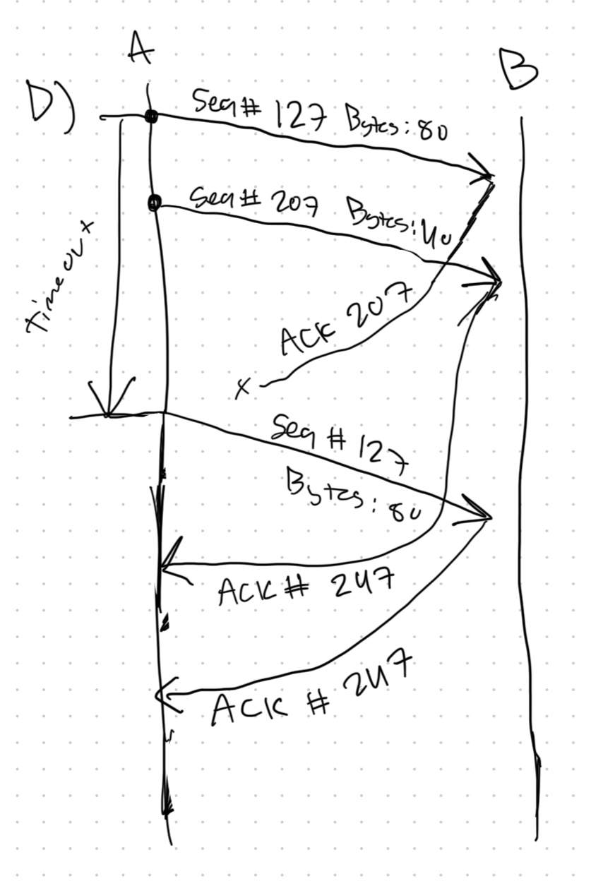D)

P28:

For TCP Flow Control, B will let A know that it can process at a rate of 50 mbps, because of this A will slow down and actually only send out data at the rate of 50mbps to avoid overflowing the Buffer at B.

P31:

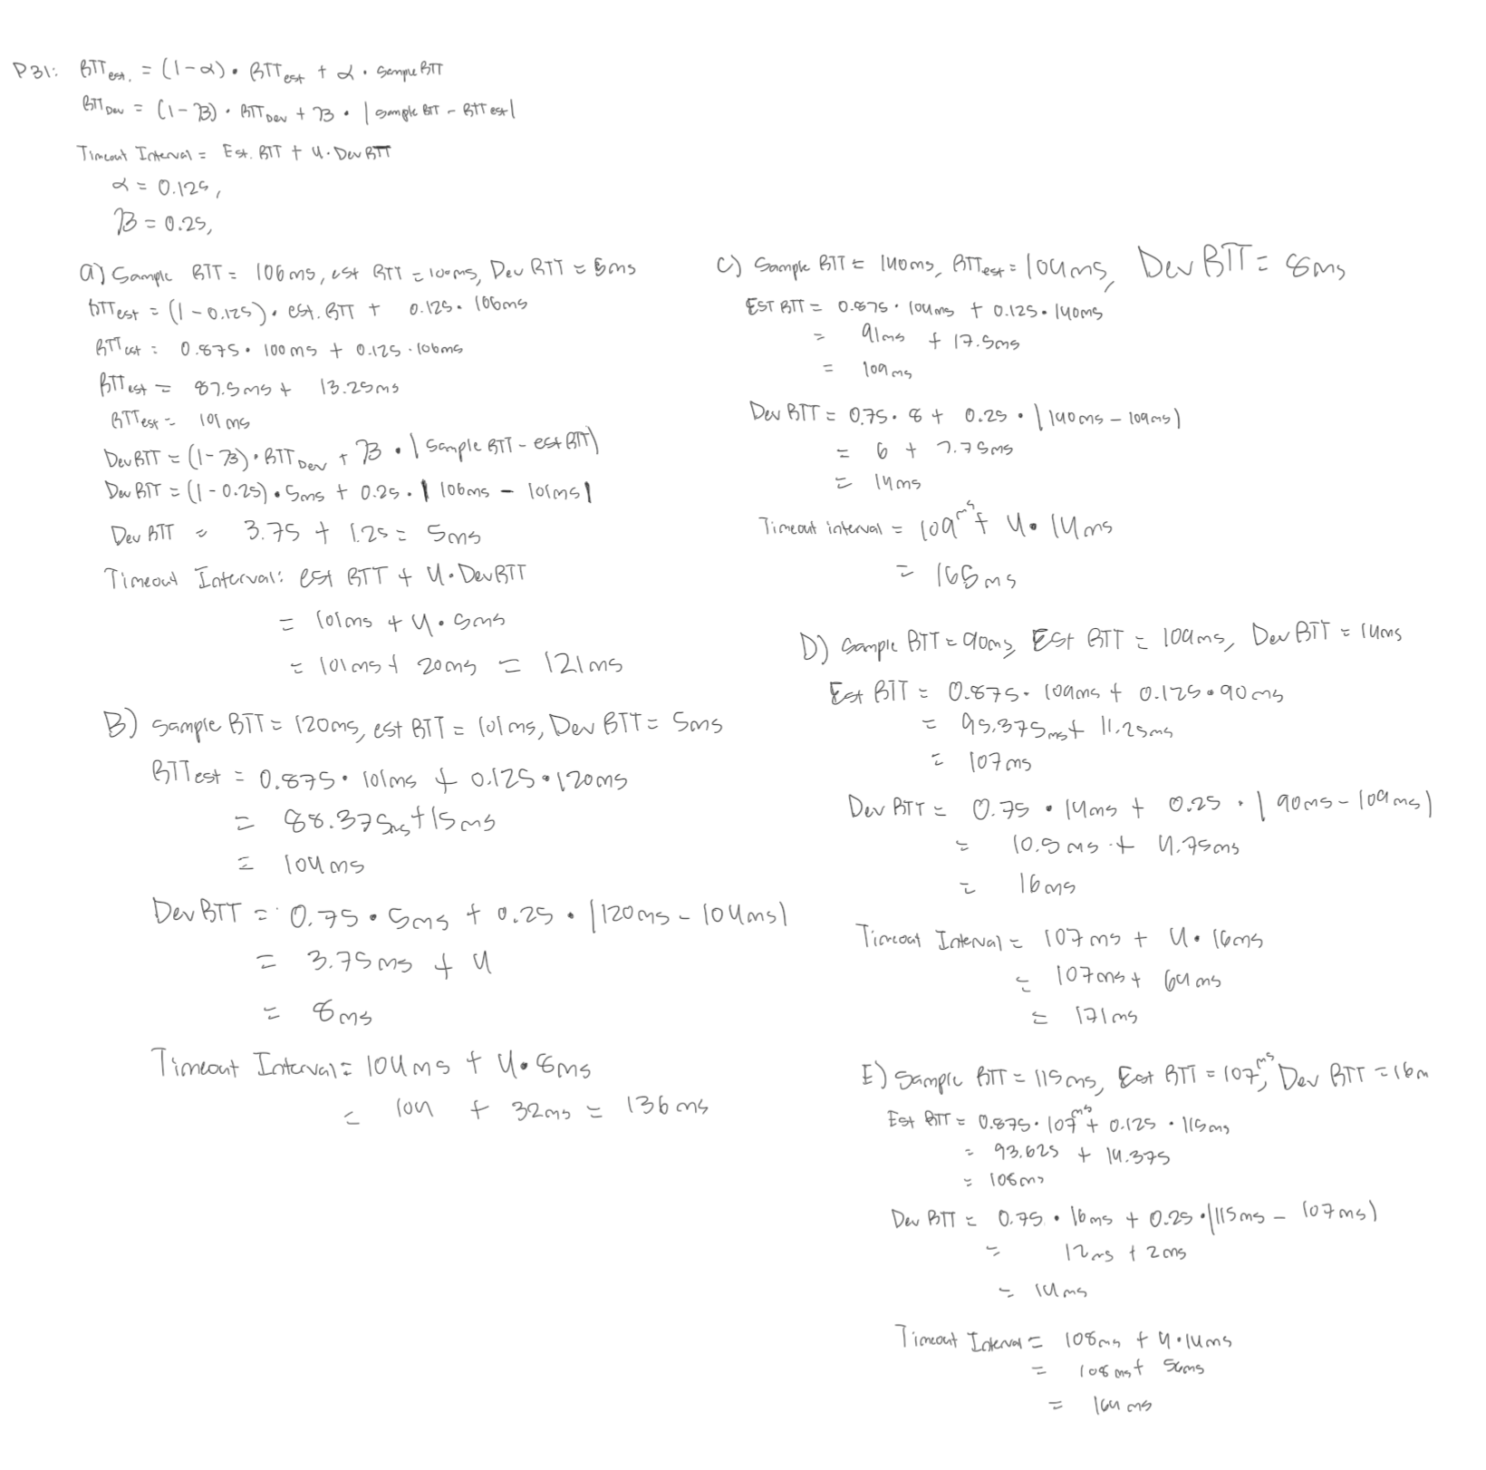

P36:

Considers factors like delay that might cause packets to arrive / be received later than expected.

P40:

A) 1 – 6, 23 – 26 is TCP Slow Start. This is b/c cwnd size is doubling every transmission round.

B) 6 – 16, 17 – 22 is TCP Congestion Avoidance. This is b/c the cwnd size is increasing linearly every transmission round.

C) Triple Duplicate ACK’s because the cwnd size was cut in half.

D) Timeout because the cwnd size reset back to 1.

E) 32 b/c it switches from exponential to linear increase.

F) 24 b/c loss event (triple duplicate ACK’s) occurs @ 16th transmission round, therefore set the threshold to half of cwnd.

G) 14 b/c loss event (timeout) occurs @ 22nd transmission round and window is ~29 therefore set ssthresh to 1/2 (29) which is ~14

H) 7th transmission round. Starts at 1 during the first transmission round then begins doubling. At the 6th round, when you total up the amount of packets sent, it accumulates to about 63 packets, which means the 7th round, will send out the 70th segment.

I) cwnd size = 8

New cwnd = 8 / 2 = 4

Threshold = ½ * 4 = 2

J) Threshold = ½ * cwnd = ½ * 42 = 21

Cwnd = 4

* Drops to 1 @ 17th transmission round, then grows exponentially.

K) 52 packets. Starts @ 1 cwnd @ the 17th transmission round, then increases exponentially until 21st round where it approaches threshold (5 packets away), adding up equates to 52.